Welcome to The Place of Providence! Let this be your guide for today!

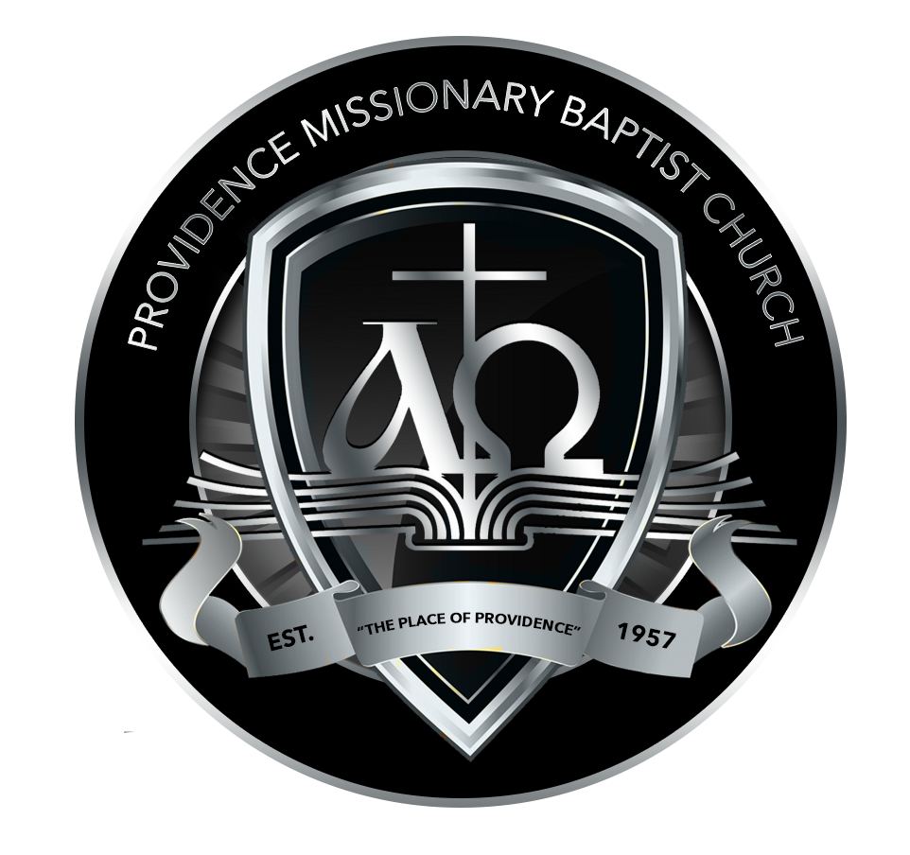

Welcome/Greetings to today’s session

Opening Prayer

Get to know you Icebreaker

The Goals of “Connect”

What it means being a “Member” of Providence/Importance of Baptism

Learning more about Ministry and Serving

Q & A Period

Dismissal Prayer

Note: Please keep your phones on you, as we will give the official time of Baptism for you. Please come with white t-shirt, or any t-shirt, with sweats or thermals. Wear a headwrap if possible. If you have already been baptized, please disregard this update.

Stay connected with Providence MBC, we will add you to our one-call system, along with texting-in our automated texting system. Text “Providence” or “All-in” to 1-833-950-9535.

Welcome to The Providence Family!
I am glad that by Divine appointment, you were led to join our family here at “The Place of Providence.” From the bottom of my heart, I am overjoyed of what God is doing, and what He is about to do in your journey. It is our desire that while growing in your relationship with God, you gain better insight into the will of God, the way that God has for you to grow through your connection to The Place of Providence. Today is your New Member orientation through only one class scheduled in-person or online. As a new member, your attendance is instrumental in ensuring that you gain knowledge and understanding regarding the vision of the church you are now connected to. The overall purpose is to inform, teach, instruct, cultivate, inspire, and get you familiar with the church, what you can expect as a member, but your Faith journey in all that God is preparing to do in your life.

We Welcome You at “The Place of Providence!”

The Goals of Connect

Once again, thank you for joining Providence Missionary Baptist Church. The following six points define the experiences for each of you over the next 12 months. They also serve as goals, which we hope you will accomplish.

1. We hope that you will develop several new and deeper relationships in the church that will enhance your experience in Christ and Providence.

2. We hope that you will feel excited now and in the future about your choice to join Providence as you allow us to guide you in being a better, more consistent and mature disciple of Jesus Christ.

3. We hope that you will make the commitment to actively engage with us over the next year.

4. We hope that you will get involved in a ministry work here at the church, one that relates to your passion. You have been saved to serve, not sit on your calling.

5. We hope that you will grow and eventually provide leadership in some areas of Providence.

6. We hope that you will work hard yearly to bring someone else into our church membership. “Each one, bring one.”

Pray the Following: “Lord, help me and give me the strength to work towards these goals, and most importantly grow in what your plan is for my life here at Providence.”

What it means being a Member/Importance of Baptism

Membership- The state of being a member; members of a body or a group, collectively.

- Membership involves commitment to worship the Lord, encouraging brothers and sisters through cooperation in mission, and holding each other accountable to walk in a manner that is pleasing to the Lord.

“So we, being many, are one body in Christ, and everyone belongs to one another.” (Romans 12:5)

- A member is a limb or an organ of the body; it’s a single part; one who belongs to an association or a group.

- You serve a purpose to the body. You have a part to play in the body of Christ.

- The Christian Church is a group of called out believers, who have gathered to do the will of God.

- The church is connected to help carry out the redemptive purpose and Ministry of our Lord and Savior Jesus Christ. This is much more than our names on a church roll.

- Jesus presents Himself as the builder of the Church. No man can build it, but Christ is the keeper of the Church. We have assurance in Jesus Christ that we are a part of something that will last us the test of time.

The Church

- The Church is referred to as the body of Christ (1 Corinthians 12:12-14 and 1 Corinthians 6:19).

- The Church is JESUS CHRIST, living in the bodies of believers who have yielded themselves to Him, so that He can abide within and direct their lives.

- You have a part to do. (1 Corinthians 12:15-16)

- You are important to that work. (1 Corinthians 12:17-27 and Ephesians 4:16)

Important Keys to know:

- We should regard church membership as the privilege of our lives.

- A person, who joins an organization, commits themselves to its support by regular attendance, personal encouragement, and financial participation.

- Pray for your spiritual growth and faithfully undergird your church in prayer.

- In this journey, it is vital to take upon (1 Thessalonians 5:17).

- The more you pray for the welfare and the works of your church, the more you will feel a vital part of it.

Baptism

- Is the public display of one’s Faith in our Lord and Savior Jesus Christ.

- (Mark 1:9-11)

- Baptism is a representation of the death, burial, and resurrection of one’s spiritual journey. When in the water, the “old” self is dead and buried, and when out of the water, it is now the resurrection of the “new” self in Jesus Christ. (2 Corinthians 5:17)

- Baptism is also a public declaration of Salvation.

Salvation is the process of one’s conversion to being Saved by Grace through Faith in Jesus Christ (Ephesians 2:8-9)

- Recognizing and knowing that we are sinful beings and have fallen short from the Glory of God (Romans 3:23)- Repentance.

- Acknowledgement that Jesus came, and died, and then rose again so that we can be right with the Father, with the confession of the mouth and belief in the heart (Romans 10:9-10) - Confession.

- You receive the gift of the Holy Spirit that dwells within you.

More about Ministry and Serving

- You have been saved to serve!

- If you are unsure about your gift(s), and what you feel led to do, please go to https://gifts.churchgrowth.org/spiritual-gifts-survey/

- There is a list of ministries to help aid and assist your journey here at Providence, alongside leaders that can help guide you.

Sunday School Ministry (Mother Betty Bell, Leader)
EmpowHER Women’s Ministry (Leading Lady Strong, Leader)
Missionary Ministry
Usher Ministry (Bro. Donnovan Johnson, Leader)
Kitchen Ministry (Sis. Leona Butler, Leader)
Nurses Ministry (Sis. Dianne Chaney, Leader)
Media Ministry
Youth Ministry (Sis. Alyssa Pickens, Leader)
Music Ministry (Sis. Dawnisha Hall, Leader, Sis. Chandra Holman-Young, Director)
Many opportunities to join us in the week
- Midweek Morning Motivation (7:00AM), Midweek Bible Study (6:00PM)-Wed
- Sunday School Christian Educational Empowerment (9:30AM Sundays in person)

Giving & Support of The Work at Providence

Giving is a part of worship, our service to God in our time, talent, and treasure. God has blessed us to be stewards over what He entrusts to our care.

- Matthew 25:14-30 illustrates the parable of the talents, an earthly story with a spiritual meaning, highlighting the importance of taking care of what God blesses us with, and being Faithful over it.

- This not only applies in financial alone, but this applies in everything that you are blessed and given. Worship is also shown in how you steward/take care of what you are given to by God.

- Psalm 24:1 reminds us that The Earth is the Lord’s. Meaning, everything belongs to the Lord. He allows us to have it. Giving says we give back what He allows us to manage.

- Time refers to your hour(s) and energy, Talent refers to the skills, gift(s), and what you bring, and Treasure refers to the financial resource(s) and material possession(s) you have.

Tithing is a Biblical command that you are given, coming from Leviticus 27:30, that says that 1/10 is “Holy to the Lord.” Malachi 3:10 is where God puts us to the test by giving our tithe to the Lord.

- As a believer, tithing is giving God 10% of what you have been blessed to have, and trusting Him with the 10%, while 90% is still yours.

- You believe what you give is what God will use to bless His house, His work, and the Kingdom, while God continues to bless your household.

- What you give, helps God’s Kingdom here at Providence, with the support of the ministry, the expenses of the church, and even benefitting programs and initiatives.

- Tithes and Offering are separate, even though they function as giving. Tithing is what you are biblically commanded to give, while offering is what you give sacrificially, on top of what you give with your tithe.

- Knowing that your giving goes a long way, should put a smile in your heart, showing in your face. You should give cheerfully, knowing that God loves a cheerful giver (2 Corinthians 9:7).

Even if you don’t have the means, and even if you do have the means, you are also given the opportunities to give in these T’s

- Your Time to God matters. God has given you time to live, and most importantly, you make time for what matters. God should be at the head and center of your life. Make time for God to serve Him in your living, taking time to grow here at your church, fellowship with others, to grow in community.

- Your Talent matters. God has given us a Spiritual Gift, an expertise God has allowed us to master. Your Church needs you, they need your Gift, so the Church can be healthy in effectiveness (1 Corinthians 12:7). Serve God, and watch what comes your way.

Once you receive what is “The Right Hand of Fellowship” at Providence, you are entitled to all rights, privileges, and responsibilities as any other member. Which includes

• Participation in Church Business Meetings
You have the right to attend and contribute to discussions regarding the direction, decisions, and stewardship of Providence.
• Voting Rights
You are eligible to vote on matters such as leadership appointments, budgets, and key ministry initiatives that impact our church community.

YOUR CONNECT NEXT STEPS
Belong. Believe. Become. Build.
Your first Connect orientation session is Sunday, August 23, 2026 at 9:30 AM, available in person or online. This one-session orientation will introduce Providence's vision, membership, baptism, ministry, serving, giving, and your next steps toward the Right Hand of Fellowship.
1. Complete Connect
Attend the orientation, participate in the conversation, and bring any questions you have about life and membership at Providence.
2. Discover Your Spiritual Gifts
Complete the online Spiritual Gifts Assessment. Use your results to begin a conversation about where God may be calling you to serve.
3. Share Your Results
After completing the assessment, email your results or questions to theplaceofprovidence@gmail.com so a Connect partner can help you explore ministry opportunities.
4. Stay Connected
Text JESUS or JOIN to 833-250-9535 for an immediate response and Daily Restoration encouragement. Text ALL-IN or Providence to the same number for church news and updates.
5. Take Your Place
Complete the welcome pathway and prepare to receive your certificate and the Right Hand of Fellowship on the following first Sunday.
Spiritual Gifts Assessment: gifts.churchgrowth.org/spiritual-gifts-survey
Questions? theplaceofprovidence@gmail.com | 833-250-9535

